[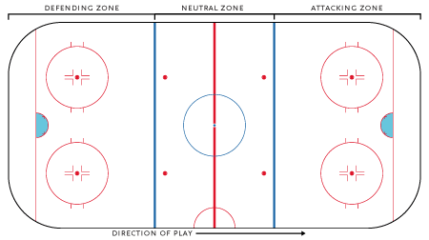](https://en.wikipedia.org/wiki/File:HockeyRink-Zones.png)

[](https://en.wikipedia.org/wiki/File:HockeyRink-Zones.png)