TIMEKEEPER CLOCK INSTRUCTIONS
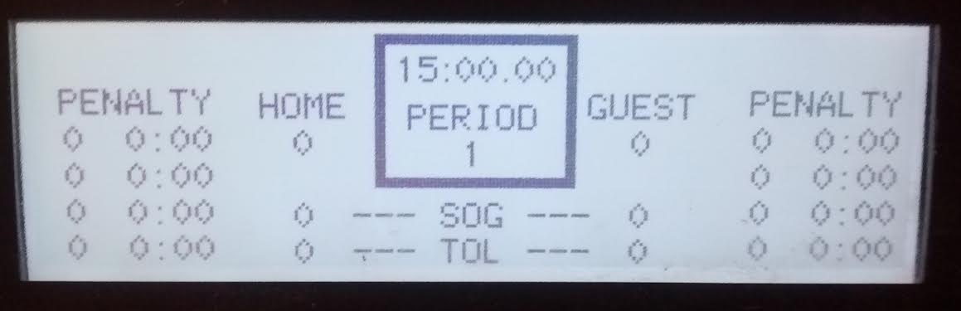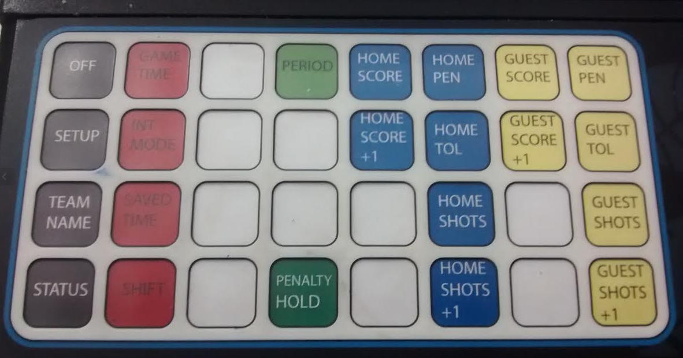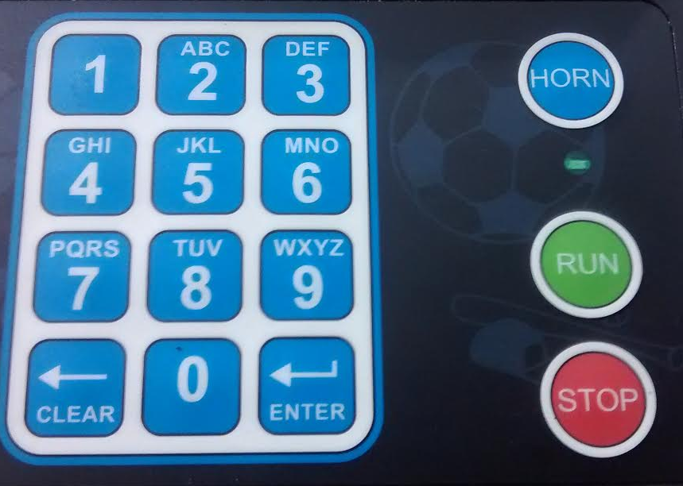
3 minute WARM-UP:
- Push the GAME TIME button and then the number 3.
- Push the ENTER button three times.
- Push the RUN button to start clock when ready.
*Start 3 minute warm-up only when both teams are on the ice. Horn will sound automatically.

The GAME:
*The computer will automatically start at the 1st Period.
- Push the GAME TIME button and enter the length of the period ie: 10 (for 10 minutes)
- Push the ENTER button three times.
- Push the RUN button to start clock when ready.
*The computer will flip to the 2nd Period automatically.
- Push the GAME TIME button and enter the length of the period ie: 10 (for 10 minutes)
- Push the ENTER button three times.
- Push the RUN button to start clock when ready.
*The computer will flip to the 3rd Period automatically.
- Push the GAME TIME button and enter the length of the period ie: 15 (for 15 minutes)
- Push the ENTER button three times.
- Push the RUN button to start clock when ready.
*The Horn will sound automatically after each period.

To START and STOP the Clock:
- Push the circular STOP button when the referee blows the whistle to stop the clock.
- Push the circular RUN button when the referee drops the puck at the face-off to start clock.

Adding a SCORE:
- Push either the 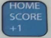 or the 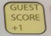 button to add the goal to the scoreboard.

Adding PENALTIES:
- Push either the 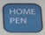 or the 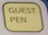 button depending.
- Using the key pad enter in the length of the penalty (ie: 2 – for a 2 min penalty)
- Push the ENTER button two times *Penalty will disappear automatically when done.

TYKE ONLY - 3 minute shift buzzer:
- Push the SHIFT button and then the number 3.
- Push the ENTER button two times.
- Push the RUN button to start clock when ready.
NOTE: You can push ENTER button to navigate through the display and the CLEAR button if you need to erase anything. You can see where you are on the computer display, when that space is flashing.

